**FINANCIAL INCLUSION AND PRADHAN MANTRI JAN DHAN YOJANA ANALYSIS**

Dissertation submitted to Guru Gobind Singh Indraprastha University

M.A. (Economics)

**Kunal Bisht**



University School of Humanities & Social Sciences

GURU GOBIND SINGH INDRAPRASTHA UNIVERSITY

New Delhi 110078

2023

**DECLARATION**

I hereby declare that the dissertation entitled “Financial Inclusion and Pradhan Mantri Jan Dhan Yojana Analysis” submitted by me under the course outline for the award of the degree of M.A. (Economics) is my work. Any part of the dissertation, if found plagiarized would solely be my responsibility and does not bear any consequences for the University or any person associated thereof.

The dissertation has not been submitted for any other degree of this University or any other University.

Kunal Bisht

**CERTIFICATE**

This is to certify that **Kunal Bisht**, University Enrollment No. 02821630721 has completed his dissertation on the topic “**Financial Inclusion and Pradhan Mantri Jan Dhan Yojana Analysis**” under my supervision as a part of his curriculum for Masters in Economics, University School of Humanities and Social Sciences, Guru Gobind Singh Indraprastha University.

Dr. Prarthna Agarwal Goel Dr. Sonali Agarwal

Coordinator, M.A. (Economics) Supervisor

USHSS

**ACKNOWLEDGEMENT**

I would like to thank my supervisor, Ms. Sonali Agarwal, for her consistent support and guidance throughout the research project. I would also like to express my gratitude to the faculty members at Guru Gobind Singh Indraprastha University for their time and efforts during the lectures which made the completion of this dissertation possible.

**Kunal Bisht**

**M.A. (Economics)**

**Guru Gobind Singh Indraprastha University, Delhi**

**Table of Contents**

1. **List of tables**
2. **List of figures**
3. **List of Abbreviation**
4. **Abstract**
5. **Chapter 1 : Introduction**

* Objective of Pradhan mantra jan dhan yojana
* Benefits of Pradhan mantra jan dhan yojana
* Financial inclusion issues and policy mesure
* Financial Inclusion Index
* Components of financial inclusion index
* Financial inclusion and economic growth

1. **Objective of the study**
2. **Chapter:2 Literature Review**
3. **Chapter:3 Data and Research Methodology**
4. **Chapter:4 Empirical Analysis and Results**
5. **Chapter:5 Conclusion**
6. **References**
7. **Appendix**

**List of Tables**

**Table 1. Descriptive statistics**

**Table 2. Correlation matrix**

**Table 3. Fixed effect regression**

**Table 4. Random effect regression**

**Table 5. Hausman test**

**Table 6. Financial Inclusion Index**

**List of Figures**

**Figure 1. Availability of banking services**

**Figure 2. PMJDY Accounts (in crore)**

**Figure 3. Deposits under PMJDY (in Rs. crore)**

**Figure 4. Deposits per a/c (in Rs.)**

**Figure 5. Heat map of financial inclusion 2014**

**Figure 6. Heat map of financial inclusion 2021**

**Figure 7. 2014 graph of Financial inclusion index**

**Figure 8. 2021 graph of Financial inclusion index**

**Figure 9. 2015 graph of Financial inclusion index**

**Figure 10. 2019 graph of Financial inclusion index**

**List of Abbreviations**

* GDP - State wise gross domestic product
* GSWFC – Gross state wise fixed capital formation
* HDI - Human development index
* FII – Financial inclusion index
* BANKAC - Numbers of accounts per 1000
* BRANCH - Number of bank branches
* CDRATIO - States credit and deposit ratio
* PMJDY – Pradhan mantra jan dhan yojana
* BCs – Business correspondents

# 

# ABSTRACT

*In this paper an attempt has been made to study the impact of Pradhan mantra jan dhan yojana on financial inclusion index across the Indian states. Using Sarma's (2008) indicator of financial inclusion, the current study creates a three dimensional financial inclusion index for 36 major Indian states between 2014 and 2021 to measure the condition of financial inclusion in Indian states. We tried to find out the relationship between FII and different variables like HDI, GDP, GSWFC through fixed effect regression and random effect regression and to choose between fixed effect and random effect we performed haussman test. The results show that GSWFC is not statistically significant because its p value is greater than 0.05. After calculating FII and creating graphs of it and studying its heat map we can say that the PMJDY programme enhanced the rate of economic growth somewhat but did not raise the overall level of economic prosperity among states.* *The main causes of the PMJDY scheme's failure include poor use of financial services and an increase in the number of inactive accounts.*

# CHAPTER 1: INTRODUCTION

The Pradhan Mantri Jan Dhan Yojana (PMJDY) is the Government of India's major financial inclusion initiative, begun in 2014. The project intends to offer unbanked and underbanked members of society, particularly those living in rural regions, with universal access to financial services. The PMJDY has been recognized as one of the world's largest financial inclusion programs, with the Guinness World Records acknowledging the opening of 18,096,130 bank accounts by the State Bank of India (SBI) in a single week in August 2014.

The plan was created with the aim of increasing financial inclusion and decreasing financial exclusion by offering basic banking services to the poor and marginalized segments of society. The PMJDY aims to provide a basic savings bank account, a RuPay debit card, and an overdraft facility to every household in the country. Account holders may also get Rs. 30,000 in life insurance and Rs. 2 lakh in accidental insurance under the plan. The initiative also attempts to increase financial literacy and awareness among the general public, particularly in rural regions.

The scheme was launched in the backdrop of the large-scale exclusion of the poor and marginalized sections of the society from the formal banking system. According to a report issued by World Bank, around 40% of the population in India was excluded from formal financial services in 2013. The lack of access to formal financial services has been a significant impediment to the socio-economic development of the country, as it has prevented people from accessing credit, insurance, and other financial services. The PMJDY aims to solve this issue by giving the public access to basic banking services, allowing them to participate in the official financial system.

**Objectives of Pradhan Mantri Jan Dhan Yojana**

The primary objective of PMJDY is to promote financial inclusion by ensuring that every household in the country has access to banking services. The project aims to attain this goal by offering basic financial services to the underprivileged and marginalized members of society. The specific objectives of the PMJDY are as follows:

1. To ensure access to financial services, including banking and credit facilities, to every household in the country.
2. To increase financial literacy and awareness among the general public, particularly in rural regions.
3. To provide a basic savings bank account, an overdraft facility and a RuPay debit card to all households in the country.
4. To offer account holders with a Rs. 30,000 life insurance policy and a Rs. 2 lakh accidental insurance policy.
5. To lower the poor's reliance on informal sources of credit, which frequently demand excessive interest rates.
6. To promote cashless transactions and decrease the use of cash in the economy.
7. To provide access to welfare programmes such as the Pradhan Mantri Jeevan Jyoti Bima Yojana (PMJJBY) and the Pradhan Mantri Suraksha Bima Yojana (PMSBY) to all households.

Throughout the country, public sector banks, regional rural banks, and cooperative banks are implementing the PMJDY. In the first phase, the scheme's goal was to open 7.5 crore bank accounts. The accounts are opened with zero balance and do not require any minimum balance to be maintained. The scheme also provides for overdraft facilities of up to Rs. 10,000 for account holders, subject to certain conditions.

The scheme has been implemented with a focus on rural areas, where the majority of the population is unbanked. The government has set up a network of business correspondents (BCs) to provide doorstep banking services in remote and inaccessible areas. The BCs are authorized agents of the banks and are responsible for opening bank accounts, accepting deposits, and providing other basic banking services. The BCs are mostly local residents, who are trained and equipped with handheld devices to carry out banking transactions.

The government has also provided financial incentives to the banks for opening PMJDY accounts. Banks are incentivized to open accounts in areas with low banking penetration, and additional incentives are provided for accounts opened for women, and for those opened in semi-urban and rural regions. Banks are additionally responsible for offering account users with free basic banking services such as ATM cards, passbooks, and chequebooks.

Approximately 41.63 crore bank accounts have been established under the PMJDY as of March 2021, with a total balance of approximately Rs. 1.4 lakh crore. The project has been quite successful in bringing the unbanked people into the official banking system. According to the Ministry of Finance, the PMJDY has led to a reduction in the percentage of unbanked households from 51.4% in 2011 to 14.6% in 2017.

The PMJDY has also played a significant role in promoting financial literacy and awareness among the masses. The scheme has been instrumental in promoting the use of mobile banking and digital transactions, thereby reducing the dependence on cash transactions. Various measures, including the use of audiovisual aids and mass media campaigns, have been initiated by the government to encourage financial literacy and awareness. The government has also provided training and capacity building programs for BCs and bank officials to enable them to provide better banking services.

**Benefits of Pradhan Mantri Jan Dhan Yojana**

The PMJDY has brought about significant benefits for the poor and marginalized sections of the society. Some of the key benefits of the scheme are:

1. Financial inclusion: The initiative has been effective in bringing unbanked people into the formal banking system, increasing financial inclusion.
2. Basic banking facilities: The scheme provides basic banking facilities such as savings bank accounts, ATM cards, and overdraft facilities to the poor and marginalized sections of the society.
3. Insurance cover: The plan offers account holders with life insurance coverage of Rs. 30,000 and accidental insurance coverage of Rs.2 lakh, therefore providing social security to the poor.
4. Cashless transactions: The scheme has been instrumental in promoting cashless transactions and reducing the use of cash in the economy.
5. Financial literacy: The initiative has played an important role in increasing financial literacy and awareness among the general public, particularly in rural regions.
6. Employment generation: The scheme has created employment opportunities for the BCs, who are mostly local residents.
7. Direct benefit transfer: The PMJDY has permitted the direct transfer of subsidies and welfare benefits to beneficiaries' bank accounts, eliminating leakages and guaranteeing that funds reach the intended recipients.

Despite the significant success of the Pradhan Mantri Jan Dhan Yojana (PMJDY), there are several challenges that need to be addressed to ensure its sustained success. Some of the major challenges faced by the scheme are:

1. Low utilization of accounts: Despite a huge rise in the number of bank accounts established under the PMJDY, a significant percentage of accounts are dormant, with low or zero balances. Many of the account holders lack the awareness or knowledge to use the banking services, and hence do not utilize the accounts to their full potential.
2. Inadequate financial literacy: Financial literacy is still a major challenge, particularly in remote places. Many account holders are unaware of the various banking services available to them and how to use them effectively. The government should spend in promoting financial literacy awareness and education programmes for the general public.
3. Lack of access to financial services: Although the PMJDY has created a network of BCs to provide doorstep banking services in remote and inaccessible areas, there are still many areas where banking services are not available. The government needs to focus on expanding the network of BCs and banks to provide financial services to all regions of a nation.
4. Cybersecurity: The increasing use of digital transactions, cybersecurity has become a major concern. There is a need to ensure that the banking system is secure and protected from cyber-attacks and fraud.
5. Financial sustainability: The PMJDY is a massive scheme, and its financial sustainability is a major concern. The government needs to ensure that the scheme is financially viable in the long run and that the banks are able to recover their costs.
6. Limited access to credit: Although the PMJDY provides account holders can get up to Rs. 10,000 in overdrafts, but credit is still limited. Due to the considerable risk involved, banks are frequently unwilling to lend loans to the poor and underprivileged parts of society.
7. Inadequate infrastructure: Inadequate infrastructure, especially in rural areas, is a major challenge. The lack of proper roads, electricity, and telecommunication facilities making things tough for the BCs to provide banking services effectively.

The Pradhan Mantri Jan Dhan Yojana is a revolutionary scheme that has brought about significant changes in the Indian banking system. The scheme has been successful in promoting financial inclusion and providing basic banking facilities to the poor and marginalized sections of the society. The PMJDY has also played a significant role in promoting financial literacy and awareness among the masses, thereby reducing the dependence on cash transactions.

However, there are several challenges that need to be addressed to ensure the sustained success of the scheme. The government needs to invest in creating awareness and education programs to promote financial literacy among the masses. It needs to expand the network of BCs and banks to provide banking services to all regions of the country. It needs to ensure the cybersecurity of the banking system and address the concerns related to financial sustainability.

The PMJDY has the potential to transform the Indian banking system and bring about significant changes in the lives of millions of people. The government needs to continue its efforts to address the challenges faced by the scheme and ensure its success in the long run.

**Financial inclusion issues and policy measures**

Financial inclusion refers to the accessibility and availability of financial services for individuals and businesses, particularly those who feel underserved or excluded from the established banking system. Given that it promotes growth, lessens poverty, and improves general well-being, it is an important component of growth in the economy. However, a number of problems with financial inclusion must be addressed along with the appropriate policy solutions.

1. Limited Access to Critical Financial Services: Many people limited access to fundamental financial services including savings accounts, credit, insurance, and payment systems, especially those who live in rural and low-income communities. Policy options for resolving this issue include:

Establishing bank branches and mobile banking services in communities where services are lacking. Encouraging the use of technology to reach rural populations, Mobile banking and digital wallets are two examples.

Promoting growth of agent banking networks, wherein approved agents can deliver fundamental financial services on banks' behalf.

2. Limited Financial Literacy: A lack of knowledge about finances significantly restricts financial inclusion. People may be hesitant to use financial products and services if they are not well informed about them. Policy actions might focus on:

Implementing in place financial literacy-enhancing programmes in communities and schools.

collaborating with nonprofit organisations and businesses to offer financial counselling and education services.

To improve comprehension and transparency, financial products and disclosure processes should be made more user-friendly and straightforward.

3. High transaction costs: People with less income may find it hard to acquire and use financial services due to their high fees and transaction costs. A policy measure could be:

Setting policies into effect to restrict excessive fees and levies for essential financial services. Encouraging financial service providers to compete in order to cut prices.

Encouraging the use of electronic payment methods, which can have cheaper transaction costs than cash-based transactions.

4. Inadequate Identification Systems: People who live in disadvantaged neighbourhoods or lack official proof of identity may find it difficult to get financial services due to a lack of proper identification documents. Policies could include:

Creating reliable and comprehensive identification systems, such as digital IDs or biometric identification.

Reaching those who are neglected by investigating alternate identifying methods, such as community-based identification processes.

Simplifying identification requirements for opening bank accounts and gaining access to financial services by working with governmental organisations and other stakeholders.

**Financial Inclusion Index**

A financial inclusion index is a tool for determining how many people and organizations have access to and utilise financial services. It provides an in-depth assessment of a country's or region's degree of financial inclusion, supporting policymakers and stakeholders in identifying gaps and developing successful financial inclusion policies.

Access to financial services, financial service usage, and financial service quality are often measured by financial inclusion indices. The number of bank accounts, ATMs, mobile money accounts, credit accounts, and the level of financial literacy are some of the regularly used indicators in financial inclusion indices.

Financial inclusion indices are essential because they can help policymakers and stakeholders establish specific strategies to improve financial inclusion by identifying areas where financial services are absent. Additionally, financial inclusion indices can be used to track progress over time, which can help to measure the impact of policies and interventions aimed at improving financial inclusion.

**Components of the Financial Inclusion Index**

The financial inclusion index is a technique for assessing how well individuals and businesses have access to and use financial services. The financial inclusion index has numerous components, including access to financial services, financial service usage and quality of financial services.

**Financial Inclusion and Economic Growth**

Financial inclusion is essential for growth in the economy. By giving individuals and businesses financial services availability, they are better able to save money, invest in their businesses, and access credit. This, in turn, helps to stimulate economic growth, create jobs, and reduce poverty.

Financial inclusion has been proven in studies to contribute to economic growth in many different kinds of ways. Firstly, financial inclusion can increase productivity by enabling individuals and businesses to access credit, which can be used to invest in new equipment, technology, and other assets. This, in turn, can help to improve efficiency, reduce costs, and increase output.

Secondly, financial inclusion can promote entrepreneurship and innovation by enabling individuals to start their own businesses. Financial inclusion could make it easier to overcome challenges to entrepreneurship and empower individuals to develop entrepreneurial ideas by giving access to finance, financial services, and business support.

Thirdly, financial inclusion can contribute to economic growth by promoting financial stability. Financial inclusion can help individuals and companies lessen their reliance on unreliable and unpredictable informal financial services by providing them with access to savings and loans.

Fourth, financial inclusion can increase social mobility by giving people access to credit, which they can use to invest in things like education, housing, and other assets. This can aid in increasing social mobility and decreasing inequality.

Financial inclusion could contribute to economic growth in a number of way. Some of the key ways are:

1. Promoting Investment: By making credit and other financial services available, financial inclusion can help to promote investment in new equipment, technology, and other assets. This, in turn, can help to improve productivity, reduce costs, and increase output.

2. Promoting Entrepreneurship: By providing individuals with access to credit, financial services, and business assistance, financial inclusion can help to boost entrepreneurship. This can help to overcome barriers to entrepreneurship and enable individuals to pursue their business ideas.

3. Encouraging Savings: Savings accounts and other financial services. Individuals can use this to develop a financial buffer and invest in their future.

4. Promoting Financial Stability: Financial inclusion may help individuals and companies survive financial shocks and lessen their dependency on informal financial institutions by providing them with access to loans.

In conclusion, financial inclusion is important for promoting economic growth, reducing poverty, and promoting equality. Financial inclusion can contribute to economic growth by promoting investment, entrepreneurship, savings, and financial stability. By promoting financial inclusion, we can create a more equitable and prosperous society for all.

**India’s Financial Inclusion Index**

India's FII increased from 53.9 in the prior year of 2021 to 56.4 in 2022.

All of its sub-indices (Access, Usage, and Equality) have shown progress. To assess the overall degree of financial inclusion in the country there are 97 indications that make up the FI-Index are responsive to service accessibility, usability, and quality.

It collects information on several dimensions of financial inclusion and converts it into a single number ranging from 0 to 1, where 0 represents absolute financial exclusion and 1 represents complete financial inclusion.

It consists of three major characteristics—Access (0.35), Usage (0.45), and Quality (0.20), weights denoted in brackets. Each of these factors has numerous dimensions that are calculated using a variety of indicators.

The index responds to all 97 characteristics for service accessibility, usability, and quality.

The contribution of finance and financial inclusion to economic progress has been enormous. Through the use of economic analysis, this connection has been shown and proven through numerous research and the development of various models.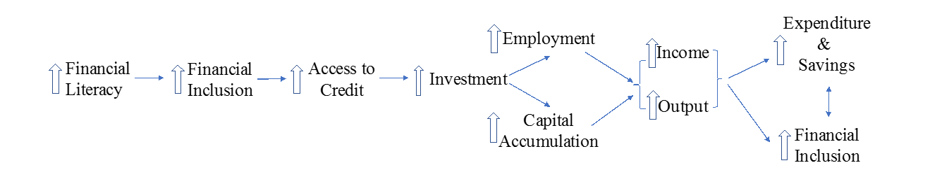The above figure shows that high financial literacy will help in increasing financial inclusion . Financial inclusion and access to credit have positive relation between them it means that when there is high financial inclusion there automatically will be high access to credit and high investments that can provide employment in the economy and country like India where employment is such a big challenge. High financial inclusion also increase the income of general population. High income will automatically increase expenditure and savings.

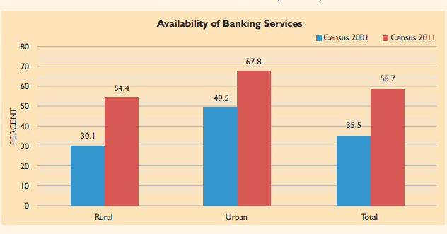

Source : pmjdy.gov.in

Despite many financial inclusion efforts, poverty and exclusion continue to dominate socioeconomic and political life. Even after six decades of post-economic independence debate in India. Though the economy grew rapidly after 1991's liberalization, the benefits have yet to reach all segments of society, and India continues to house one-third of the world's impoverished. According to the 2011 Census, just 58.7% of households have access to financial services. As on 29 may 2023 49.03 Crore beneficiaries banked so far ₹197,193.68 Crore Balance in beneficiary accounts 8.50 lakh Bank Mitras delivering branchless banking services in the Country.

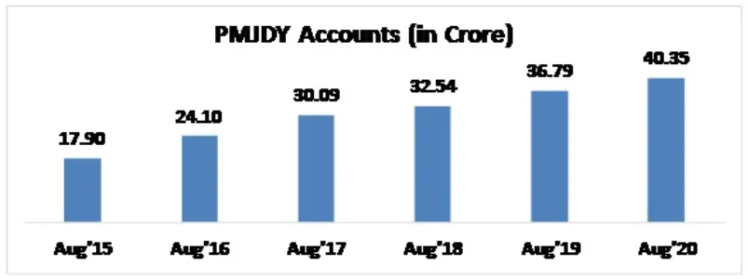

Source : faceless compliance

As of August 19, 2020, the total number of PMJDY accounts was 40.35 crore, with rural PMJDY accounts accounting for 63.6% and women PMJDY accounts accounting for 55.2%. During the scheme's first year, 17.90 crore PMJDY accounts were opened. The number of accounts under PMJDY continues to grow. According to current RBI criteria, a PMJDY account is considered inactive if there have been no customer-initiated transactions in the account for more than two years. In August 2020, 34.81 crore (86.3%) of the total 40.35 crore PMJDY accounts were operational. The continuous growth in the percentage of operational accounts indicates that more and more of these accounts are being utilised on a regular basis by consumers.

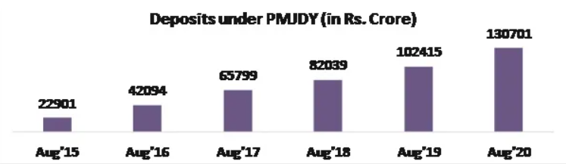

Source : faceless compliance

The total deposit balance in PMJDY Accounts is Rs. 1.31 lakh crore. Deposits have grown around 5.7 times, while accounts have increased 2.3 times (Aug'20 / Aug'15).

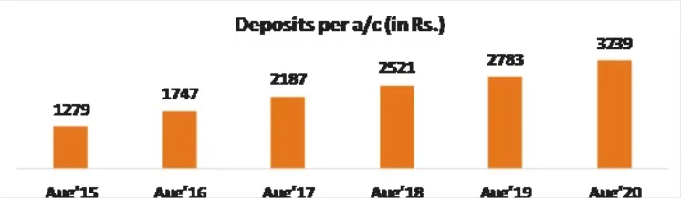

Source : faceless compliance

The average deposit per account is Rs. 3239. Deposits per account have climbed more than 2.5 times since August of 2015. An rise in average deposit is another evidence of increasing account usage and the instillation of a saving habit among account holders.

OBJECTIVE OF THE STUDY

* + - 1. To look into the impact of financial inclusion promoted under the PMJDY scheme on economic growth in Indian states between 2014 and 2021.
      2. To see the relation between Financial inclusion and HDI, GDP, GSWFC.

# CHAPTER 2:

# LITERATURE REVIEW

Previously papers are published on this topic which talks about the financial inclusivity of common population (Financial Inclusion and Pradhan Mantri Jan Dhan Yojana: An Empirical Study Conducted in the villages of Mulshi Taluka in Pune District. **Thirumagal. J. Pillai**) the purpose of this study is to investigate farmers' understanding of Jan Dhan Yojana, as well as their adoption or acceptance of these program in the Pune. The data is selected through a questionnaire or as mentioned in paper through structured interview schedule and discussions. The sample size consist of 62 farmers. The study's conclusion is that the overall research suggests that the benefits of the PMJDY Scheme are not being fully utilized. Despite having complete access to their bank accounts, actual data suggests that farmers only have a limited knowledge of the benefits system. Rural communities still need to free themselves from the control of moneylenders, manage new financial needs, and take use of the variety of financial services provided by PMJDY program. The goal of the scheme might not be achieved by simply opening bank accounts ongoing operation of bank accounts is necessary for the scheme to be truly successful.

Another paper of **Singh, B. P., Kumari, A., Sharma, T., & Malhotra, A**. (2021) took the financial inclusion index (FII) on the lines of the UNDP HDI measure. Their study shows that FII (financial inclusion index) shows a modest increase in the degree of financial inclusion. In 2018, the average FII value increased from 0.121 in 2011 to 0.146. Central, eastern, and northern districts are performing badly in terms of financial inclusion and are classified as having low financial inclusion.

Another conceptual study was conducted by **Sharma and Dr. goyal** (2017). A study has been done to determine the success rate of the inclusion procedure in rural regions of the Jaipur district. They chose a Jaipur district and performed a correlation (r) test to determine the association between socioeconomic backgrounds and the financial inclusion process. According to their findings, respondents are more likely to feel financially involved when they live closer to the bank. Financial information from a number of sources (Bank Mitr, newspaper, media, friends, etc.) has contributed in the inclusion of more individuals. As a result, banks and governments should work closely together to communicate financial information since they see a direct influence on their operations. Only one respondent reported getting financial information from the bank, showing that banks' attempts to communicate financial information have been ineffective.

**Dr. Shettar** (2016) (Pradhan Mantri Jan Dhan Yojana: Issues and Challenges) gives a descriptive research on Pradhan Mantri Jan Dhan Yojana. Her goal was to investigate the current status of Pradhan Mantri Jan Dhan Yojana, difficulties, and challenges of the system. She conducted a descriptive research. Data is gathered from secondary sources such as government publications, published articles, journals, newspapers, reports, books, and the Pradhan Mantri Jan Dhan Yojana (PMJDY) official website. According to her research, the number of accounts established under the Pradhan Mantri Jan Dhan Yojana initiative has dramatically grown. To achieve the goal of inclusive growth of the country in the context of the globalised world, it is crucial to financially involve all societal segments in this plan. PMJDY is a nationwide financial inclusion initiative that focuses on individual families and aims to provide formal financial assistance inside the current banking system. The viability of the PMJDY plan is dependent on an effective regulatory structure, in that stakeholders must develop a sustainable environment to keep the accounts open and the programme running properly.

**Gupta** (2015) The efficiency of the Pradhan Mantri Jan Dhan Yojana (PMJDY) and the most recent advances that PMJDY is bringing into reality for financial inclusion. Only 28% of the Jan Dhan Yojana accounts are active, with around Rs. 9, 000 crores deposited in them. This compared to the government's disclosure of 64% of accounts created at private banks. Harpreet Kaur and Kawal Nain Singh (2015) investigated the most recent trends in financial inclusion in India, focusing on the Pradhan Mantri Jan Dhan Yojana (PMJDY) and suggesting ways to ensure that as many underprivileged and unbanked areas as possible are included in the financial system.

**RoopKumar and Sharma** (2018) conducted an Emperical study of Jan Dhan Yojana And Jan Suraksha Scheme they selected data from secondary sources the writer use Spatial analysis statewise and use the heat map across the country for more clear representation of the data. They concluded that in comparison to when the plan was launched, the average daily enrollment has showed a decreasing trend, although it is obvious that average daily deposits are rising.

**Shylaja** (2021) have conducted an empirical study on the Pradhan Mantri Jan Dhan Yojna and Financial Inclusivity, with the goal of analysing the progress made in terms of expanding banking services under the PMJDY. With improved financial accessibility, banks have moved closer to the last mile client through branches. An attempt is also made to comprehend, from the standpoint of business correspondents, their observations regarding the beneficiaries' banking habits both before and after the PMJDY. She concluded that the Pradhan Mantri Jan Dhan Yojana's have raised the awareness among the previously excluded, who are now more responsive to using various banking services and have begun to connect into the formal banking sector. Because more people are involved in the mainstream financial sector, there will be more opportunities for businesses because more money will be moving about the economy.

**Singh & Tandon** (2013) highlighted the need of banks adapting their business practises in order to support low-income populations' financial inclusion, and of viewing the entire financial inclusion process as both a commercial opportunity and a social obligation.

According to **Paramasivan and Ganeshkumar's** (2013) study, branch density significantly affects financial inclusion. According to a study financial inclusion and economic growth in Kenya are strongly correlated. Nitin Kumar uses empirical data from 29 major states between 1995 and 2008 in his study. The outcome demonstrates that, as indicated by penetration measures, the supply side of financial services enhances banking activity. According to the study, socioeconomic factors and the local environment play a significant role in influencing people's banking habits.

A recent study by **Kunthai** (2014) on the recent developments of financial inclusion in India with a particular focus on the national mission of "Pradhan Mantri Jan-Dhan Yojna (PMJDY)" has evaluated the progress, roadblocks, in the process of financial inclusion and has suggested strategies to improve the coverage of banking in rural populations for Pradhan Mantri Jan-Dhan Yojna (PMJDY)".

**Kumar and Joseph** (2017) a study on the Antecedents of Pradhan Mantri Jan Dhan Yojana (PMJDY) Account Usage Among Rural Customers The study attempts to investigate the motivations for creating a Pradhan Mantri Jan Dhan Yojana account, as well as the frequency of transactions and usage patterns. The study's scope is focused to the Dindigul district and its client base is public sector banks. The objective of this study is to to determine the factors that led rural Pradhan Mantri Jan Dhan Yojana users to open accounts (PMJDY) and to examine the Pradhan Mantri Jan Dhan Yojana (PMJDY) account holders' post-account opening transactional usage patterns. The study use both primary data and secondary data. Secondary data were gathered from the Dindigul district's head bank office. To achieve the research goal, an interview schedule with both planned and unstructured questions was used. In the Dindigul district, data are gathered from respondents in a variety of blocks using a convenient sampling technique. Thirty samples were used in a pilot study, and all psychometric assessments were completed. Afterwards, 100 samples of data from PMJDY account holders were obtained and used for additional analysis. The study summarizes that most consumers opened their bank accounts with the intention of saving money and 100 days of employment. Understanding why rural clients save money in their bank accounts might help one better comprehend this behaviour. The majority of rural clients prefer saving for managing the expenditure and savings for their children's education. Also, rural consumers prefer saving when running small business. It was discovered that the main motivation for maintaining the account was solely to get or withdraw government benefits, which is a serious problem. So, it cannot be said that there is a major variation in the frequency of savings by gender. The level of bank account utilization among rural PMJDY clients does not significantly differ depending on demographic factors including age, gender, income, and distance to the bank branch. As a result, there is no clear relationship between age group and bank account usage.

**Ms. Gupta** (2022) did a study with the objective of to examine the rise in beneficiaries, deposits into their accounts, and the issue of Rupay Debit Cards at Public, Private, and Regional Rural Banks across the country are all part of the Pradhan Mantri January Yojana. They conducted their research using secondary data and found that the goal of the Jan Dhan Yojana is to financially involve every sector of society by increasing understanding of financial tools. One notable accomplishment of this yojana is the opening of 12.54 crore accounts as of January 31, 2015, as compare to the target of 7.5 crore bank accounts for 21.06 crore households by the same date. It is giving the rural, urban, and even female segments of the country a universal platform to gain access to various financial services like as the RuPay card, Bank Mitra, insurance, credit, and pension services, among others.

According to **Badar Alam Iqbal** (2017), financial inclusion is crucial for the development of society and the nation's economy. It benefits in closing the wealth disparity. The article's goal is to look at the present situation of financial inclusion in India, the key issues limiting access to it, and the effects this has on the expansion of the Indian economy. A multiple regression model was used to analyse secondary data that was gathered from reports from the GOI, RBI, and Ministry of Finance over a seven-year period (from 2007-2008 to 2013-2014). It was determined that financial inclusion is linked to economic growth and development, and that financial inclusion requires effective regulation in order to access financial services. It was also determined that financial literacy programmes needed to be set up.

**DR.A.Tamilarasu** (2014)Financial inclusion, according to analysis is a good idea that offers rural residents possibilities for boosting banking services. But, it requires a suitable system to direct all available resources towards customers. The investigation on the number of banks, the number of people working in each office, the total amount of deposits and credit issued, and the number of ATMs installed between 2008 and 2013 was done. It was discovered that the impoverished segment's relationship with financial service providers had been neglected as the focus was mainly on building no-frills accounts.

According to **Allen** (2012), people must rely on informal financial means to satisfy their financial demands in the absence of financial inclusion. As a result, obstacles to financial inclusion like high account fees, long distances, and limited acceptable products must be removed. In order to increase the number of eligible account users and the frequency of current users, a research was undertaken using data from 123 countries to discover successful strategies among financially excluded individuals and characteristics of financially included people through formal accounts. Financial inclusion was found to be improved by an environment that makes it easier to access branches, requires less paperwork to open an account, and is less expensive.

**Irrinki and Burlakanti** (2017) shows in their study that The majority of people are aware of the Pradhan Mantri Jan Dhan Yojana. 40% of those surveyed learned about it via bank employees, while 21% of people learned about it from friends and family. 66% people opened their account under this scheme.

**Singh and Koden** (2016) using the financial inclusion index, researchers investigated the relationship between financial inclusion and economic development. Regression analysis is used in the study to identify the factors related to financial inclusion. The analysis of the survey, which encompassed 15 states, revealed a favourable relationship between socioeconomic progress and financial inclusion. Similar findings indicates that there is no substantial link between employment, education, and gender and financial inclusion.

**Prabhu P** **V** (2011) had shown how poor had not seen the same impact as the financial sector on progress. Those who lack basic financial services are also those who miss out on the advantages of economic progress. There should be inclusive development for the advancement of society in order to overcome this. The increase in financial inclusion through credit cooperatives is examined in this research. Together with the expansion of other economic sectors, the growth of the agricultural sector and the rural economy should be prioritized in the effort to end poverty. The GDP growth will be improved as a result.

**Senapati** (2018) did study with the objective to analyze the progress of financial inclusion of people in odhisa and he finds that the number of accounts registered under PMJDY has multiplied since the scheme's introduction in 2014. The PMJDY initiative works to ensure that all vulnerable and underprivileged groups in society have access to banking services and small loans. Despite the fact that there have been many financial inclusion initiatives undertaken in the past, PMJDY has great relevance because of its size, geographic scope, scale of impact, and engagement of crucial parties, including the government, banks, and regulators. As a result of the Pradhan Mantri Jan Dhan Yojana (PMJDY), approximately 98% of Indian families now have bank accounts. PMJDY has so far put up an impressive performance.

**Dasgupta** (2009) emphasised that financial inclusion should provide services like saving, insurance, and other facilities in addition to serving the aim of granting credit. All of this is feasible either through encouraging literacy or by receiving sound guidance from bank employees. (Kamath 2007) made a similar remark about the necessity of including a neglected segment of society in a related research.

**Verma and Garg** (2016) did an analysis with the objective of to measure awareness and usage of the scheme. Overall findings are consistent with the widespread belief that individuals in rural areas are somewhat less aware of financial and banking services. Many surveys and studies show that poverty and illiteracy are widespread in villages, and this is mirrored in the current study. In the real world, villagers are uncomfortable using a number of banking services, such as a debit card, credit card, or insurance services. The study's findings further support the notion that the majority of respondents had never utilised financial services. In terms of the country's financial and banking knowledge, it is evident that the study's findings reflect the reality of the situation.

**Dr. Umamaheswari K, Dr. Kumar, Dr. Vidhya K** (2022) they did an analysis with the aim to identify the main factors influencing the saving habits of Pradhan Mantri Jan Dhan Yojana Scheme they get to know from their study that although this programme has been successful in reaching rural regions, there is still a lack of knowledge. In order to educate the public, the government might host an awareness camp. All households can access financial goods and services from PMJDY at a lower cost, including savings, transactions, credit, payments, pension, and life and health insurance.

**Nimbrayan** (2018), showed in their study that financial inclusion will help the underprivileged in entering the primary foundation of growth, as well as financial institutions the chance to work together on inclusive growth. Financial inclusion is critical to India's long-term economic growth and development. Without financial inclusion, inclusive growth is ultimately impossible. The nation's economic progress also depends on financial inclusion. The PMJDY is an ambitious program for financial inclusion overall.

**Dey** (2022)did a study to see the performance of pradhan mantra jan dhan yojana in different states the analysis takes into account all 28 of India's states as well as nearly all of its major banks. The data will just come from secondary data sources. From 2015 to 2019, secondary sources have been used to examine the data. He concluded his study by saying that financial inclusion expands the base of the nation's financial system's resources by instilling a saving and investing culture among a significant chunk of the rural population, particularly the underprivileged. In its own unique manner, it contributes significantly to the process of economic growth. Including low income groups in the formal banking industry helps to safeguard the resources and financial wealth of account holders under trying circumstances. By enabling simple access to formal credit, financial inclusion assists the impoverished in escaping the grasp of moneylenders. The PMJDY, which aims to address these issues, is at the heart of the Government "Sab Ka Saath, Sab Ka Vikas" development ideology. Although in this current age of science and technology with mobile and online banking, PMJDY primarily focuses on the groups of people who are kept out of the fundamental banking and financial institutions. It is true that the PMJDY scheme will offer social security to all homes in the nation. The government will now make it simple for people to get subsidies in their designated bank accounts. The viability of this system depends on political will, bureaucratic assistance, and RBI monitoring and oversight. PMJDY is anticipated to unleash the enormous untapped potential of the bottom rung of the Indian economy's pyramid.

**Awasthi, A.** (2015) finds out in his study that the financial inclusion is listed as the primary goal of the Pradhan Mantri Jan Dhan Yojana, yet unrealistic objectives and hasty estimates are causing this scheme to fail. Financial inclusion is a gradual process, and promoting financial literacy is essential to its success. If financial literacy rises naturally, the demand for financial goods will rise as well.

**Dr. Thyagarajan and Prof. Nair** (2016) According to their study, the Indian government and reserve bank have been making a variety of initiatives to encourage financial inclusion of the general public with the primary goal of providing financial services to the financially excluded segment of society.

(Hussain) It is considered that the introduction of PMJDY has brought the idea of financial inclusion to the forefront. Due to its distinctive features, it is now one of the greatest programmes for attaining financial inclusion. The three primary pillars of this programme, which is especially helpful to the poor, are the Ru Pay Card, Insurance, and Overdraft Facility. Yet, the lack of public understanding of PMJDY's advantages and its services is its biggest downside. In order to raise knowledge of the program's advantages, extensive publicity is required.

**Joshi and Rajputrohit** (2016) published a paper Pradhan Mantri Jan Dhan Yojana (The Financial Inclusion) to study the awareness of Pradhan mantri jhan dhan yojana they collected primary data and they run hypothesis testing on their data . In this study they concluded that government consistently working for the betterment of rural customer. Compared to the previous Swabhimaan programme, they have some success raising awareness about the new financial inclusion strategy PMJDY. However, government has not yet been able to considerably raise rural customers' understanding.

In this study they also got to know that there is not enough exposure for the rural population they don’t understand the importance of these kinds of scheme. They concluded by saying that Government must try to educate rural customers about the importance of various banking services to better their financial condition in order to improve the results of the financial inclusion plan.

According to **Bagli** (2012), there is a substantial relationship between the human development and their financial inclusion. Additionally, he concluded that improving financial inclusion would be beneficial for governments, financial regulators, and other entities that set policy, but that as of now, the situation of the Indian states is not desirable. He has also come to the conclusion that financial inclusion cannot be achieved without widespread financial literacy and awareness among the underprivileged groups of society.

Financial inclusion, according to **Chowhan & Pande** (2014), protects low income group’s. By making it simple to obtain formal credit, financial inclusion also reduces the exploitation of weaker groups by predatory lenders. The Pradhan Mantri Jan Dhan Yojna is an essential component of the Government of India's development ideology of Sab Ka Saath Sab Ka Vikas, which seeks to reduce such sufferings. In forecasting a brighter future for PMJDY, they also stated that due to its enormous success, bank managers will be able to understand and take advantage of the opportunity provided by financial inclusion by taking part in government program to reduce poverty for those who are most at risk, increasing their deposit base through the government's direct fund transfer program, etc.

**Balasubramanian** (2015) has emphasized the importance of financial knowledge with a focus on the habit of saving among those who are poor. The decision tree model he constructed showed that the number of wage earners in the family, the size of the family, the average monthly income and job type are deterministic independent factors that influence low income population's regular saving behaviours.

According to **Kaur & Singh** (2015), India's government and bankers will be able to tap into the unrealized potential of the country's bottom-of-the-pyramid sector of the economy. The widely lauded and successful introduction of PMJDY program has also reinforced the view that when all constituents and stakeholders collaborate, a framework that operates as a dominating force for mission fulfilment is created. They have also suggested that coordination, dedication, commitment, formalization, dependency, trust, satisfaction, cooperation, and continuity reinforce this notion.

In his research, **Raval** (2015) stressed the significance of including members of lower socioeconomic classes in economic development. Such a move by the Indian government is represented by PMJDY. He also looked into the possibility of a "excluded segment" programme succeeding if the government enlisted the support of the commercial sector and involved the public in ways other than just drafting policies.

# CHAPTER 3:

# DATA

# AND

# RESEARCH METHODOLOGY

**Data**

Three dimensions of financial inclusion is used in this study: availability, penetration and usage to calculate the FII index from 2014 to 2022 for 36 major Indian states. We took financial variables such as numbers of accounts per 1000 (BANKAC), number of bank branches (BRANCH), and states credit and deposit ratio (CDRATIO) is used, which is also a measure of penetration, availability and usage of the banking system respectively. All the data are collected from the publication of Economics and Politics Weekly Research Foundation (EPWRF). Growth domestic product (GDP) data is taken as proxy for economic performance, and gross state wise fixed capital formation (GSWFC) is taken as proxy for capital stock. Both variables are available from the 2019 edition of the RBI Handbook of Statistics on the Indian Economy. Finally, data on the human development index (HDI) is obtained from the Global Data Lab.

**Penetration Dimension**

This indicates the total number of people who have accessed the formal financial system. We gave a weight of one to the penetration dimension, which is the number of accounts with financial institutions per 1000 adults (BANKAC).

**Availability Dimension**

This indicator measures the geographic or demographic penetration of financial services through the outlets of financial institutions, such as offices, branches, and ATMs. The number of offices in various states (BRANCH) indicates the availability of financial services. This variable is given a weight of 0.6.

**Usage Dimension**

This indicator measures how frequently and adequately people use certain services. It expresses the use of financial services as a credit and deposit ratio (CDRATIO). We gave the utilisation dimension a weight of 0.5.

**Methodology**

**Construction of FII**

The three-dimensional FII applied in this research for analysis is built using the methods given in the article by Sarma (2008). Penetration, availability, and usage are the three aspects of financial inclusion that were taken into consideration when building the current FII. For each dimension, an index is calculated.

Equation (1)'s formula is used to calculate a point in the three-dimensional Cartesian space, which is also three-dimensional.

*di* = *wi* [(*Ai* − *mi*)/(*Mi* − *mi*)] , (1)

Where wi is the weight associated with dimension i, with a range of 0 to 1, Ai is the dimension's actual value, and mi is its minimum value, financial inclusion dimension i is called di, and its maximum value is Mi.

Equation (1) is determined by empirical observations. Every dimension will have a weight that will always be between 0 and 1. The higher the value of di, the greater the success in dimension i.

|  |  |  |  |  |  |  |  |
| --- | --- | --- | --- | --- | --- | --- | --- |
|  | ***HDI*** | ***BANKAC*** | ***CDRATIO*** | ***BRANCH*** | ***GSWFC*** | ***FII*** | ***GDP*** |
| **Mean** | 0.671291667 | 49333.08681 | 54.28298611 | 3934.203509 | 1012799.74 | 0.437243874 | 43711408.32 |
| **Standard Error** | 0.003090109 | 3461.207089 | 1.675921988 | 247.5662305 | 98084.04303 | 0.018629768 | 3199343.774 |
| **Median** | 0.677 | 30671.5 | 44.2 | 2404 | 275105 | 0.369185566 | 22914312 |
| **Mode** | 0.654 | 0 | 35.3 | 13 | 0 | 0 | 0 |
| **Standard Deviation** | 0.052440891 | 58738.63209 | 28.44133927 | 4179.398996 | 1664541.407 | 0.31615764 | 54294664.28 |
| **Sample Variance** | 0.002750047 | 3450226900 | 808.9097792 | 17467375.97 | 2.7707E+12 | 0.099955654 | 2.94791E+15 |
| **Kurtosis** | -0.793661437 | 2.602297632 | -0.292920291 | 0.916533582 | 8.884178839 | -1.339049005 | 2.941615013 |
| **Skewness** | -0.134821387 | 1.574893851 | 0.718826822 | 1.141810057 | 2.818403467 | 0.391268354 | 1.669255174 |
| **Range** | 0.225 | 283999 | 131.5 | 18112 | 10320287 | 0.997349821 | 273455153 |
| **Minimum** | 0.549 | 0 | 0 | 13 | -355371 | 0 | 0 |
| **Maximum** | 0.774 | 283999 | 131.5 | 18125 | 9964916 | 0.997349821 | 273455153 |
| **Sum** | 193.332 | 14207929 | 15633.5 | 1121248 | 291686325 | 125.9262358 | 12588885597 |
| **Count** | 288 | 288 | 288 | 285 | 288 | 288 | 288 |
| **Largest(1)** | 0.774 | 283999 | 131.5 | 18125 | 9964916 | 0.997349821 | 273455153 |
| **Smallest(1)** | 0.549 | 0 | 0 | 13 | -355371 | 0 | 0 |
| **Confidence Level(95.0%)** | 0.006082151 | 6812.569701 | 3.298657106 | 487.2975241 | 193055.3019 | 0.036668303 | 6297153.536 |

Table1. Descriptive statistics

Table 1 shows the descriptive statistics for the variables in the research. The mean value of BANKAC, BRANCH, CDRATIO, GDP, GSWFC, FII, HDI are 49333.08681, 3934.203509, 54.28298611, 43711408.32, 1012799.74, 0.437243874, 0.671291667 respectively. The HDI skewness is near to zero, reflecting normalcy. Kurtosis is < 3 for BANKAC, CDRATIO, BRANCH, GDP, HDI and FII implying a lighter tail. However, the other variables in the data set are non-normal and have a thick tail.

Table 2. Correlation matrix

|  |  |  |  |  |  |  |  |
| --- | --- | --- | --- | --- | --- | --- | --- |
|  | ***HDI*** | ***BANKAC*** | ***CDRATIO*** | ***BRANCH*** | ***GSWFC*** | ***FII*** | ***GDP*** |
| **HDI** | 1 |  |  |  |  |  |  |
| **p value** |  |  |  |  |  |  |  |
| **BANKAC** | -0.0943 | 1 |  |  |  |  |  |
| **p value** | 0.72883 |  |  |  |  |  |  |
| **CDRATIO** | 0.5278* | -0.0146 | 1 |  |  |  |  |
| **p value** | 0.0356 | 0.9573 |  |  |  |  |  |
| **BRANCH** | -0.0636 | 0.9982* | 0.0453 | 1 |  |  |  |
| **p value** | 0.8149 | 0 | 0.8677 |  |  |  |  |
| **GSWFC** | -0.0963 | 1* | -0.0186 | 0.9980* | 1 |  |  |
| **p value** | 0.7226 | 0 | 0.9456 | 0 |  |  |  |
| **FII** | 0.9821* | -0.0891 | 0.3588 | -0.0686 | -0.0904 | 1 |  |
| **p value** | 0 | 0.7428 | 0.1724 | 0.8006 | 0.739 |  |  |
| **GDP** | -0.0964 | 1* | -0.0187 | 0.9980* | 1* | -0.0905 | 1 |
| **p value** | 0.7225 | 0 | 0.9453 | 0 | 0 | 0.7389 |  |

Table 2 represents the correlation matrix of the considered variables.

The value of di in equation 1 is the normal value of any indicator for any given dimension, where a larger value of di signifies more accomplishment of an economy in that dimension. The next stage is to compute FII for an economy i using the following formula, which is based on the concept of accomplishment point distance (X = d1,d2,d3) between a worst (O = 0,0,0,0) and an ideal scenario (W = w1,w2,w3).

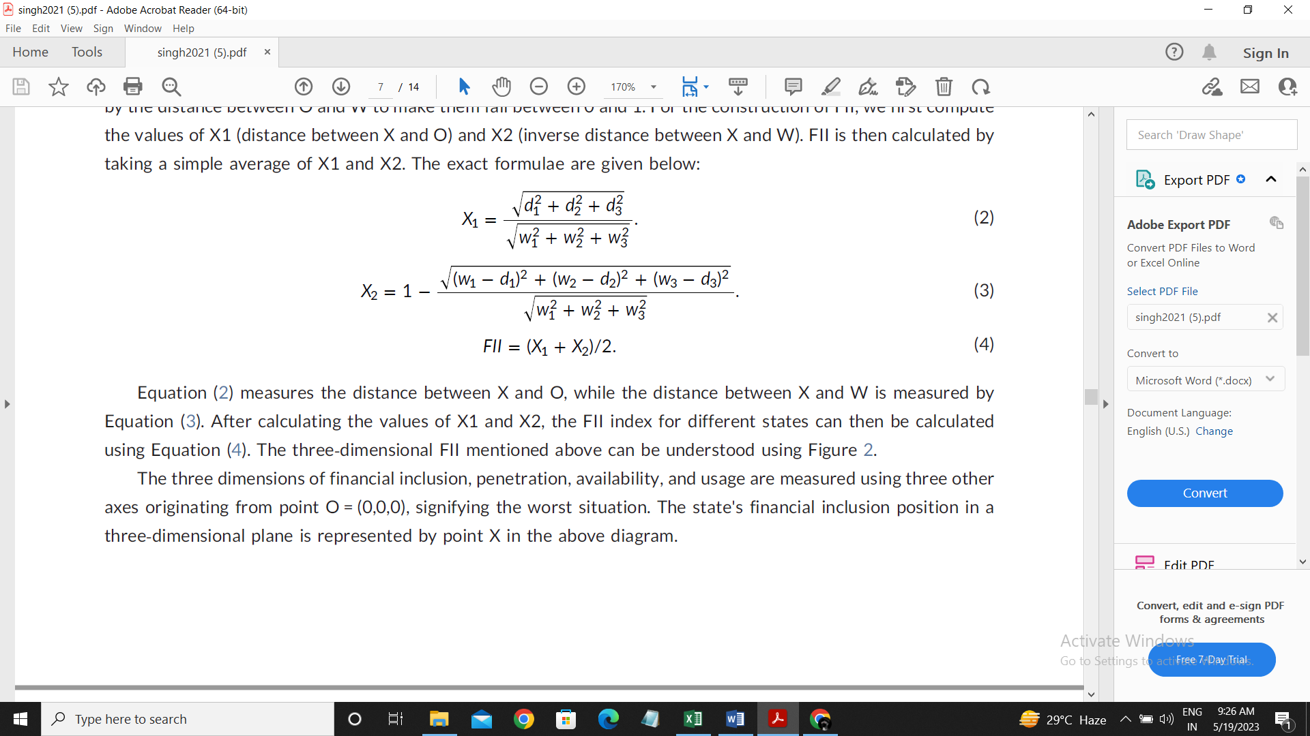



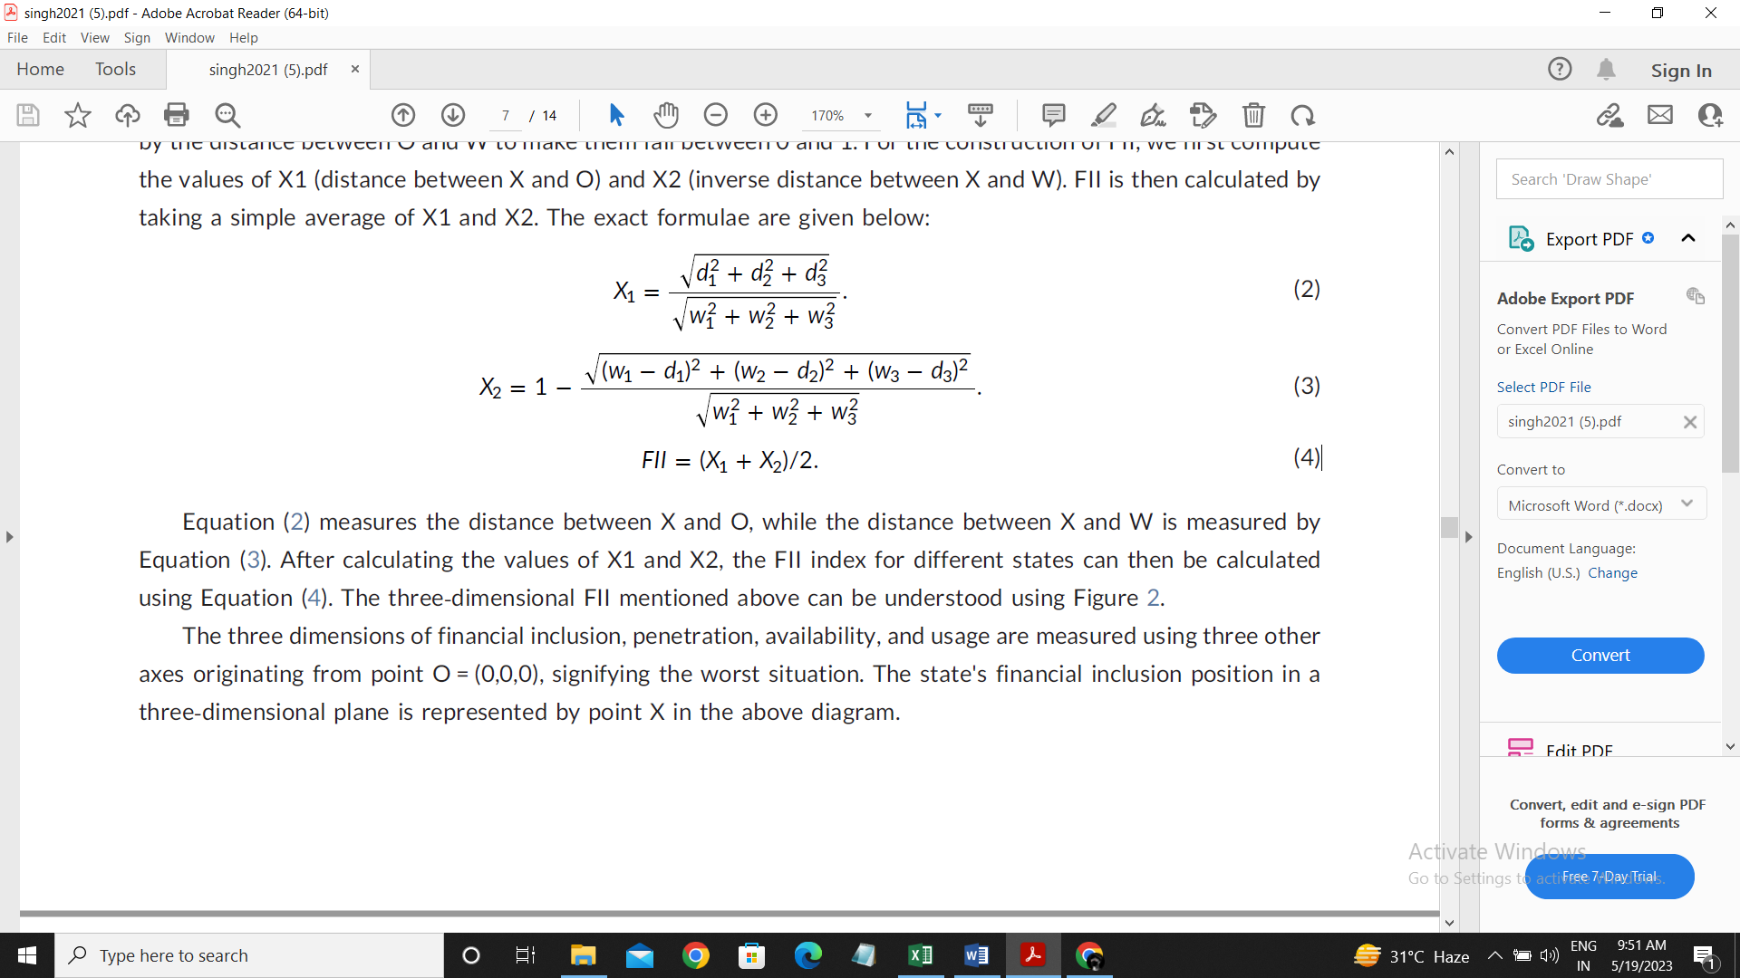

Equation (2) measures the distance between X and O, whereas Equation (3) measures the distance between X and W. Equation (4) can be used to compute the FII index for different states after computing the values of X1 and X2.

**Dynamic panel model and econometric specification**

The following model is used to see the impact of our variables such as HDI, GSWFC, GDP on

FII of 36 different Indian states from 2014 to 2021:

*FIIit* = *δ*0 + *δ*1 *HDIit* + *δ*2 *GSWFCit* + *δ*3*GDPit* + *υit*, (5)

In equation number (5) FII (Financial inclusion index) is dependent variable and remaining variables HDI (Human Development Index), GSWFC (State wise gross fixed capital), GDP(State Wise Growth Domestic Product ) are independent variables.

First we run fixed effect regression in our model we got output as

Table3: Fixed effect

|  |  |
| --- | --- |
|  | (1) |
| VARIABLES | FII |
|  |  |
| GDP | 6.32e-10*** |
|  | (1.09e-10) |
| HDI | 1.904*** |
|  | (0.356) |
| GSWFC | -7.57e-10 |
|  | (8.43e-09) |
| Constant | -0.868*** |
|  | (0.239) |
|  |  |
| Observations | 288 |
| Number of state_r | 38 |
| R-squared | 0.247 |

Standard errors in parentheses

*** p<0.01, ** p<0.05, * p<0.1

source : self computed

The within R-squared value is 0.2467, indicating that approximately 24.67% of the variation in the dependent variable is explained by the independent variables at the individual level. The between R-squared and overall R-squared values are much lower, suggesting that the group-level and overall variation in the dependent variable is not well explained by the independent variables.

The F-statistic is 26.97, with a p-value of 0.0000, indicating that the overall regression model is statistically significant.

The coefficients represent the estimated effect of each independent variable on the dependent variable, holding other variables constant.

A one-unit increase in GDP is associated with a 6.32e-10 unit increase in the dependent variable (with a standard error of 1.09e-10). The coefficient is statistically significant (p < 0.001).

A one-unit increase in HDI is associated with a 1.903734 unit increase in the dependent variable (with a standard error of 0.3563677). The coefficient is statistically significant (p < 0.001).

The coefficient for GSWFC is not statistically significant (p = 0.929), suggesting that it does not have a significant effect on the dependent variable.

The intercept term represents the estimated value of the dependent variable when all independent variables are zero. In this case, it is estimated to be -0.8675801 (with a standard error of 0.2388417). The intercept is statistically significant (p < 0.001).

The sigma_u value is 0.3208947, representing the standard deviation of the individual-specific random effects. The sigma_e value is 0.05608009, representing the standard deviation of the idiosyncratic error term. The rho value is 0.97036351, indicating that approximately 97.04% of the total variance in the dependent variable is due to individual-specific random effects.

The F-test tests the hypothesis that all individual-specific random effects are zero. The F-statistic is 103.76, with a p-value of 0.0000, suggesting strong evidence against the null hypothesis. This indicates that the individual-specific random effects are statistically significant and the fixed-effects model is appropriate.

Overall, the regression results suggest that FII and GDP have significant effects on the dependent variable, while GSWFC does not have a significant effect when controlling for individual-specific fixed effects. The intercept term is also significant, indicating a non-zero baseline value for the dependent variable.

Then we run random effect regression in our model we got

Table4: Random effect

|  |  |
| --- | --- |
|  | (1) |
| VARIABLES | FII |
|  |  |
| GDP | 7.32e-10*** |
|  | (1.16e-10) |
| HDI | 1.220*** |
|  | (0.336) |
| GSWFC | 1.53e-08* |
|  | (8.48e-09) |
| Constant | -0.438* |
|  | (0.228) |
|  |  |
| Observations | 288 |
| Number of state_r | 38 |

Standard errors in parentheses

*** p<0.01, ** p<0.05, * p<0.1

source : self computed

The within R-squared value is 0.2215, indicating that approximately 22.15% of the variation in the dependent variable is explained by the independent variables at the individual level. The between R-squared and overall R-squared values are higher compared to the fixed-effects model, suggesting that a larger proportion of the variation in the dependent variable is attributed to the independent variables at the group-level.

The Wald chi2 test is not reported in the output, as indicated by the '.'. This suggests that the statistical significance of the overall model is not provided.

The coefficients represent the estimated effect of each independent variable on the dependent variable, accounting for both individual-specific random effects and the variation at the group-level.

A one-unit increase in GDP is associated with a 7.32e-10 unit increase in the dependent variable (with a standard error of 1.16e-10). The coefficient is statistically significant (p < 0.001).

A one-unit increase in HDI is associated with a 1.219573 unit increase in the dependent variable (with a standard error of 0.3358436). The coefficient is statistically significant (p < 0.001).

The coefficient for GSWFC is not statistically significant at the conventional significance level (p = 0.070), although it is marginally close to being significant.

The intercept term represents the estimated value of the dependent variable when all independent variables are zero. In this case, it is estimated to be -0.438058 (with a standard error of 0.2280464). The intercept is marginally significant (p = 0.055).

The sigma_u value is 0.19170771, representing the standard deviation of the individual-specific random effects. The sigma_e value is the same as in the fixed-effects model, 0.05608009, representing the standard deviation of the idiosyncratic error term. The rho value is 0.92117225, indicating that approximately 92.12% of the total variance in the dependent variable is due to individual-specific random effects.

Overall, the random-effects GLS regression suggests that FII and GDP have significant effects on the dependent variable, while GSWFC does not have a statistically significant effect at the conventional level. The intercept term is marginally significant, indicating a non-zero baseline value for the dependent variable. Compared to the fixed-effects model, the random-effects model allows for group-level variation in the dependent variable and provides higher R-squared values for the between and overall variations.

To choose between fixed effect and random effect we do haussman test

Table4: Hausman test

|  |  |  |  |  |
| --- | --- | --- | --- | --- |
|  | Coeffecient | |  |  |
|  | FE | RE | Difference | S.E. |
| GDP | 6.32E-10 | 7.32E-10 | -9.98E-11 | . |
| HDI | 1.903734 | 1.21957 | 0.684161 | 0.11919 |
| GDWFC | -7.57E-10 | 1.53E-08 | -1.61E-08 | . |

source: self computed

Test: Ho: difference in coefficients not systematic

chi2(1) = (b-B)' [(V_b-V_B)^(-1)](b-B)

= 32.95

Prob>chi2 = 0.0000

The Hausman test is used to determine whether the fixed-effects (within) model is preferred over the random-effects model or vice versa. The test compares the consistency and efficiency of the two models by examining the difference between their estimated coefficients.

When the p-value of the Hausman test is zero (p = 0.0000), it suggests strong evidence against the null hypothesis that the random-effects model is consistent and efficient. In other words, the fixed-effects model is preferred over the random-effects model based on this test.

The result implies that there are unobserved variables, individual-specific effects, or other factors that are correlated with the independent variables and may lead to biased estimates in the random-effects model. By choosing the fixed-effects model, you are accounting for these unobserved factors and obtaining consistent and efficient estimates.

It's important to note that the decision to use the fixed-effects model should not solely rely on the Hausman test result. Consider other factors such as theoretical considerations, the nature of the data, and the assumptions of the models when choosing the most appropriate regression approach for your analysis

**EMPIRICAL FINDINGS**

**Status of Financial Inclusion across the Indian states**

From 2014 to 2021, the FII is computed for 36 main Indian states. A higher index value reflects a better level of financial inclusion and development. Based on previous empirical research of financial inclusion, states are classified as low, medium, or high financial inclusion. If FII is less than 0.3, it indicates poor financial inclusion. if FII is between 0.3 and 0.5 it denotes medium financial inclusion, whereas FII between 0.5 and 1 denotes high financial inclusion.

Financial inclusion status Indian of states from 2014 to 2021 shown in Table 3.

We can see that in 2014 after the introduction of PMJDY scheme 12 states are under high category for financial inclusion and before that on 2011 only one state which is Goa is in the high category (singh, 2021). But there are 21 states in the low category which is not a good signal for scheme but the scheme was introduced in 28 august 2014 so the time period is very low to see any effect on financial inclusion index. In 2021 there are 16 states in high category which is an achievement for PMJDY scheme because when it started there are only 12 states in the high category yes we can say that the growth is slow but we have to keep in mind that this is covid19 time period most of the commercial banks were not working at its full capacity and people also did not came out of their houses because of lockdown. We can see that in year 2019 before covid19 there are 16 states in the high category, 3 states in the medium category. In 2014 Goa was in medium category and in 2015 it enters the high category. Andaman nicobar island came constantly in the low category because it has very low availability of financial services there are only 59 offices in 2014 and 72 in 2021 and inn 2021 only 583 accounts are opened per 1000 population which is low so to improve financial inclusion condition of Andaman nicobar island government have to open more branches or offices in island which will help the availability dimension and people can avail financial services easily.

|  |  |  |  |
| --- | --- | --- | --- |
| **Year** | **State** | **FII** | **category** |
| 2014 | Andaman and Nicobar Islands | 0.095758199 | low |
| 2014 | Andhra Pradesh | 0.991102436 | high |
| 2014 | Arunachal Pradesh | 0.062538652 | low |
| 2014 | Assam | 0.244818337 | low |
| 2014 | Bihar | 0.544966977 | high |
| 2014 | Chandigarth | 0.272930447 | low |
| 2014 | Chhattisgarh | 0.259066673 | low |
| 2014 | Dadra and Nagar Haveli | 0.09972238 | low |
| 2014 | Daman and Diu | 0.055397025 | low |
| 2014 | Goa | 0.416726878 | medium |
| 2014 | Gujarat | 0.279993539 | low |
| 2014 | Haryana | 0.625214526 | high |
| 2014 | Himachal Pradesh | 0.358822737 | medium |
| 2014 | Jammu and Kashmir | 0.158207079 | low |
| 2014 | Jharkhand | 0.212454509 | low |
| 2014 | Karnataka | 0.431810103 | medium |
| 2014 | Kerala | 0.769665934 | high |
| 2014 | Lakshadweep | 0.446506312 | medium |
| 2014 | Madhya Pradesh | 0.205325318 | low |
| 2014 | Maharashtra | 0.704254561 | high |
| 2014 | Manipur | 0.796603621 | high |
| 2014 | Meghalaya | 0.089666006 | low |
| 2014 | Mizoram | 0.074847578 | low |
| 2014 | Nagaland | 0.09503284 | low |
| 2014 | New Delhi | 0.160244687 | low |
| 2014 | Orissa | 0.394899002 | medium |
| 2014 | Puducherry | 0.187133959 | low |
| 2014 | Punjab | 0.516131887 | high |
| 2014 | Rajasthan | 0.580566428 | high |
| 2014 | Sikkim | 0.068052858 | low |
| 2014 | Tamil Nadu | 0.995151403 | high |
| 2014 | Telangana | 0 | low |
| 2014 | Tripura | 0.097964475 | low |
| 2014 | Uttar Pradesh | 0.943326671 | high |
| 2014 | Uttarakhand | 0.178429026 | low |
| 2014 | West Bengal | 0.799956964 | high |

Table5: Financial Inclusion Index

|  |  |  |  |
| --- | --- | --- | --- |
| **Year** | **State** | **FII** | **category** |
| 2021 | Andaman and Nicobar Islands | 0.112658845 | low |
| 2021 | Andhra Pradesh | 0.94587435 | high |
| 2021 | Arunachal Pradesh | 0.069552182 | low |
| 2021 | Assam | 0.455832529 | medium |
| 2021 | Bihar | 0.891590322 | high |
| 2021 | Chandigarth | 0.234757122 | low |
| 2021 | Chhattisgarh | 0.437769185 | medium |
| 2021 | Dadra and Nagar Haveli | 0.091791429 | low |
| 2021 | Daman and Diu | 0 | low |
| 2021 | Goa | 0.494715338 | medium |
| 2021 | Gujarat | 0.330816097 | medium |
| 2021 | Haryana | 0.845294649 | high |
| 2021 | Himachal Pradesh | 0.47740597 | medium |
| 2021 | Jammu and Kashmir | 0.181501578 | low |
| 2021 | Jharkhand | 0.295730556 | low |
| 2021 | Karnataka | 0.61851701 | high |
| 2021 | Kerala | 0.899894419 | high |
| 2021 | Lakshadweep | 0.575597962 | high |
| 2021 | Madhya Pradesh | 0.254399857 | low |
| 2021 | Maharashtra | 0.940651847 | high |
| 2021 | Manipur | 0.859258105 | high |
| 2021 | Meghalaya | 0.151397648 | low |
| 2021 | Mizoram | 0.105131177 | low |
| 2021 | Nagaland | 0.108148212 | low |
| 2021 | New Delhi | 0.197412484 | low |
| 2021 | Orissa | 0.632174354 | high |
| 2021 | Puducherry | 0.164986493 | low |
| 2021 | Punjab | 0.64203935 | high |
| 2021 | Rajasthan | 0.915582109 | high |
| 2021 | Sikkim | 0.092128202 | low |
| 2021 | Tamil Nadu | 0.978568687 | high |
| 2021 | Telangana | 0.734648272 | high |
| 2021 | Tripura | 0.132900843 | low |
| 2021 | Uttar Pradesh | 0.943853414 | high |
| 2021 | Uttarakhand | 0.237749982 | low |
| 2021 | West Bengal | 0.920082503 | high |

FINANCIAL INCLUSION HEAT MAP

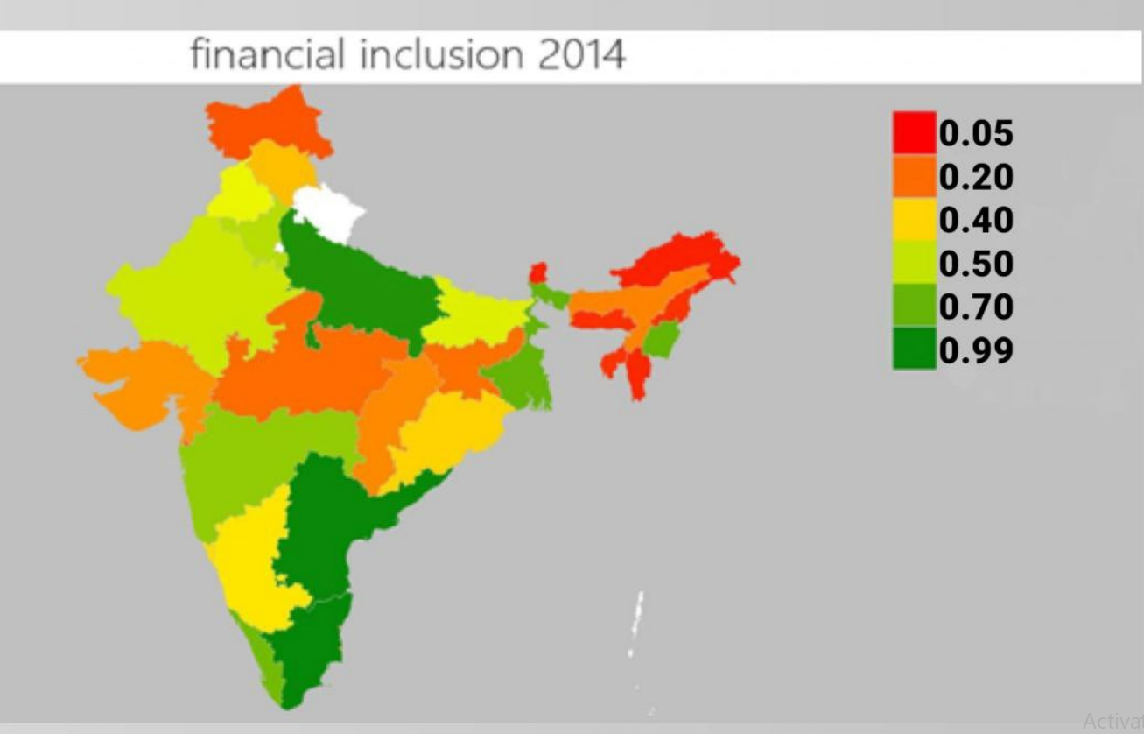

The above figure shows a heat map of 2014 when the Pradhan mantri jan dhan yojana introduced. Red color indicates low financial inclusion whereas dark green color indicates high financial inclusion. We can see the north eastern states are mostly red whereas southern states of India are green this indicates high financial inclusion in southern states. States colored in yellow and light green are indicating medium category of financial inclusion.

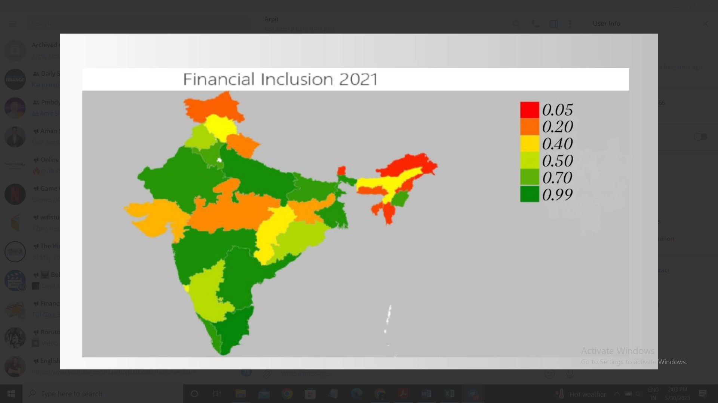

The above figure shows the financial inclusion status of Indian states in 2021 through a heat map where green color indicates high category, red color indicates low category and yellow and light green color shows medium category. We can see progress of PMJDY scheme by comparing the two figures of 2014 and 2021 which are 8 years apart. Assam improved and came in medium category in 2021 whereas in 2014 it was in low category. Maharashtra came in high category in 2021 whereas in 2014 it was in medium category. Many states improved some states are same as in 2014 like most of north eastern states government have to pay attention towards these states also and open more branches and provide more financial services in these states.

We can see in above figure the graphs showing financial inclusion index. The highest graphs in the figure is for Andhra Pradesh, Manipur, Tamil Nadu and Uttar Pradesh it means that there is high financial inclusion and on the other hand states like Andaman and nicobar, Arunachal Pradesh, Daman and diu etc. whose graphs values are near to zero shows low financial inclusion status.

Above figure shows the FII in 2021 for 36 states we can see that in 2014 there was 21 states in the low category but in 2021 there are 17 states in the low category only 4 states came out of low category. The work under PMJDY is low as only 4 states came out of low category.

Above figure shows the status of financial inclusion in 2015 goa came to medium category because the financial inclusion index of goa is .05 and the limit for medium category is 0.3 to 0.5 and in 2016 goa enters the high category.

In year 2019 there are 16 states in the high category for financial inclusion and 17 countries in low category and remaining 4 in medium category. Government have to increase the dimension of penetration, usage and availability. Government should inform about financial services to the people of low category state and try to open more branches there and pay extra attention in low category areas.

# CHAPTER 5

# CONCLUSION

The purpose of this study was to look at the effect of financial inclusion promoted by the PMJDY plan on economic development in Indian states from 2014 to 2021. Based on previous empirical investigations, a three dimensional FII is created for 36 Indian states to accomplish this objective. The relationship between financial inclusion and growth is investigated in a dynamic panel model using a composite FII and other financial inclusion proxies.

The study's finding suggests that 16 Indian states fall under the low level of financial inclusion from 2014 to 2021. In the year 2014, 11 states was under a high level of financial inclusion. Five states were under the medium level of financial inclusion, and the remaining 20 states were under a low level of financial inclusion. The PMJDY scheme launch in the year 2014, there has been a marginal improvement in the states' financial inclusion status. In 2021,15 states are under high financial inclusion, and medium financial inclusion states remained 5 in the year 2021.

We performed several regressions keeping the FII (Financial Inclusion Index) as a dependent variable and HDI, GSWFC, GDP are independent variable. First we run Fixed effect regression in which all independent variables are significant except GSWFC. Then we run Random effect regression and GSWFC is still showing insignificant to decide which model use we perform haussman test and it shows the p value 0 which means we have to proceed with fixed effect model. GSWFC showing insignificant result because of two reasons multicollinearity and data limitation. The data for GSWFC for year 2021 is not available. Data available on GSWFC is only till 2020 and our study contains a time period from 2014 to 2021. That’s why because of limitation of data GSWFC showing statistically insignificant result.

Overall, the results show a favourable and serious relationship between overall FII, penetration, and usage of financial inclusion and economic development. The results demonstrate that the PMJDY program boosted the speed of economic growth in Indian states but did not raise the overall level of economic prosperity across states. The failure of the PMJDY scheme has numerous limits, including poor use of financial services and an increase in the number of dormant accounts. To obtain better economic results from financial inclusion schemes, the government should focus on factors of financial inclusion such as human development, physical infrastructure, and governance factors such as rule of law.

In conclusion, the Pradhan Mantri Jan Dhan Yojana (PMJDY) has proven to be a transformative initiative in promoting financial inclusion in India. Since its launch in 2014, the scheme has made significant strides in providing banking services to the unbanked population and ensuring their access to financial products and services.

The PMJDY aimed to address the barriers that marginalized sections of society faced in accessing formal financial services, such as the lack of documentation, infrastructure, and awareness. By offering a comprehensive package that included a zero-balance bank account, debit card, and access to insurance and pension schemes, the scheme successfully attracted millions of previously unbanked individuals into the formal financial system.

One of the remarkable achievements of the PMJDY is the rapid expansion of banking services in rural areas. It has played a crucial role in bridging the rural-urban divide by extending financial services to remote locations. The availability of banking services in these areas has empowered individuals and communities by providing them with a secure place to save, enabling them to participate in the formal economy, and facilitating access to credit for entrepreneurial activities.

Furthermore, the PMJDY has also played a pivotal role in promoting financial literacy and awareness among the previously unbanked population. The scheme's focus on financial education has enhanced people's understanding of banking services, promoting responsible financial behavior, and helping them make informed decisions about their savings, investments, and insurance needs.

The impact of the PMJDY can be seen in various socioeconomic indicators. The scheme has reduced the dependence on informal and unregulated financial channels, minimizing the risk of exploitation and improving financial security. It has facilitated direct benefit transfers, ensuring that government subsidies and welfare benefits reach the intended beneficiaries efficiently. Additionally, the scheme has contributed to the formalization of the economy, enabling better monitoring of financial transactions and reducing the prevalence of black money.

While the PMJDY has made substantial progress, there are still challenges that need to be addressed to achieve comprehensive financial inclusion. Access to credit remains a significant concern, particularly for small and marginalized entrepreneurs. Efforts should be made to improve the availability and affordability of credit to promote entrepreneurship and economic growth. Additionally, expanding the range of financial services, such as micro-insurance and micro-pensions, can further enhance the financial well-being of the marginalized population.

In addition to the positive impact of the Pradhan Mantri Jan Dhan Yojana (PMJDY) on financial inclusion, it is important to acknowledge the wider implications and benefits that arise from a more inclusive financial system.

Firstly, the PMJDY has contributed to poverty reduction and economic empowerment. By providing access to formal banking services, individuals are better equipped to manage their finances, save money, and build assets. This, in turn, enables them to invest in education, healthcare, and income-generating activities, lifting them out of poverty and creating opportunities for economic growth.

Moreover, financial inclusion promotes gender equality and women's empowerment. The PMJDY has recognized the importance of including women in the formal financial system, and special efforts have been made to ensure their participation. Through the scheme, women have gained financial independence, improved decision-making power within households, and increased access to credit and savings facilities. This has not only improved their own lives but also contributed to the overall development of communities and societies.

Furthermore, the PMJDY has played a significant role in advancing digital financial services and promoting a cashless economy. The provision of debit cards, mobile banking, and online transactions has enabled individuals to engage in secure and convenient financial transactions. This shift towards digital transactions has the potential to reduce corruption, enhance transparency, and promote economic efficiency.

Additionally, the PMJDY has fostered financial stability and resilience at both the individual and national levels. Through the scheme, individuals are encouraged to save money in formal bank accounts, making them less vulnerable to financial shocks and emergencies. At the macroeconomic level, a more inclusive financial system reduces the reliance on informal channels and strengthens the overall stability of the financial sector.

It is worth noting that the success of the PMJDY and financial inclusion is not limited to India alone. The lessons and experiences gained from this initiative can serve as a valuable blueprint for other countries striving to achieve similar goals. The PMJDY has demonstrated the importance of political will, targeted policies, and robust infrastructure in promoting financial inclusion and empowering marginalized populations

In conclusion, the Pradhan Mantri Jan Dhan Yojana has been instrumental in bringing millions of unbanked individuals into the formal financial system, promoting financial inclusion, and fostering socioeconomic development. By continuing to address the remaining challenges and building upon the successes of this initiative, India can further strengthen its financial ecosystem and ensure that every citizen has access to the benefits of a secure and inclusive financial system.

REFERENCES

* J . pillai ,(2016) “Financial Inclusion and Pradhan mantra jan dhan yojana : an empirical study conducted in village of Mulshi Taluka in Puna district” , Indian Journal of Science and Technology .9 (45). 1-6.
* Singh, B. P., Kumari, A., Sharma, T., & Malhotra, A. (2021). Financial inclusion, pradhan Mantri jan Dhan Yojna scheme and economic growth: evidence from Indian states. *Economic Notes*, *50*(3), e12186.
* Sharma and Dr. Goyal ,(2017) “Pradhan Mantri Jan Dhan Yojana (PMJDY)- A Conceptual Study” .International Journal of Research . 5 (4). 143-152.
* Dr. Shettar , (2016) “Pradhan Mantri Jan Dhan Yojana: Issues And Challenges” . IOSR Journal Of Business And Management . 18 (2). 17-24.
* Gupta , (2015) “Pradhan Mantri Jan – Dhan Yojana : An Effort Towards Financial Inclusion” IUP Journal of Bank and Management .14 (2). 49-56.
* Roopkumar And Sharma (2018) ,“Emperical Study of Jan Dhan Yojana and Jan Suraksha Scheme” , BIMAQUEST The Journal of Insurance , Pension and Management . 18 (1). 25 - 39
* Shylja (2021) .”Pradhan Mantri Jan Dhan Yojana and Financial Inclusivity : An Empirical Analysis”, Sdmimd Journal of Management . 41-53.
* Singh, Anurag, & Tandon, P. (2013). “Financial inclusion in India: An analysis”. International Journal of Marketing, Financial Services & Management Research, 1(6), 41–54
* Paramasivan & Ganeshkumar. (2013). “Overview of Financial Inclusion in India”. International Journal of Management and Development Studies, 2(3), 45–49
* Nitin Kumar, (2013) “Financial inclusion and its determinants: evidence from India”, Journal of financial economic policy,5 (1), 4-19.
* Kunthai, R. (2014) “A studies on PMJDY: A new drive towards financial inclusion in India” Zenith International Journal of Business Economics and Management Research, 4(11), 10.
* Kumar, R. M., & Joseph, C. S. (2017). Antecedents on Usage of Pradhan Mantri Jan Dhan Yojana (PMJDY) Accounts among Rural Customers. *Asian Journal of Management*, *8*(4), 1237-1241.
* Gupta, P., & Gulati, N. (2022). An analysis of efficiency of financial inclusion through Pradhan Mantri Jan Dhan Yojana in Indian Banking sector. *SAARJ Journal on Banking & Insurance Research*, *11*(4), 1-15.
* Badar Alam Iqbal, S. S. (2017). “Role of banks in financial inclusion in India”. Contaduría y Administración .62(2). 644–656.
* DR.A.TAMILARASU. (2014). “Role Of Banking Sectors On Financial Inclusion Development In India – An Analysis”. Galaxy International Interdisciplinary Research Journal .2(2).39-45 .
* Franklin Allen, A. D.-K. (2012). “The Foundations of Financial Inclusion:Understanding Ownership and Use of Formal Accounts”. The World Bank , Development Research Group,Finance and Private Sector Development Team. 27. 1-30.
* Irinki K. Mohan and Bulakanti Kuberudu (2017). “Perception on Pradhan Mantri Jan Dhan Yojana – A Study with reference the Thallarevu Madal” . International Journal of Research , 5 (6). 2394-3629.
* Kuldeep Singh and Anand Singh Koden(2016), “Financial Inclusion, Development and Its Determinate: A Empirical Evidence of Indian States”, Axen Economic Review. 53(1). 23-27.
* Prabhu P V(2011) “Financial Inclusion Structure and States of Co-operative Credit and Banking Sector in India”, Vinmaya. 32(2). 13-17.
* Senapati (2018) .“ A study of Pradhan Mantri Jan Dhan Yojana (PMJDY) Scheme in Odhisa and Challenges of Financial Inclusion” . International Journal of Research in Humanities Arts and Literaure. 6 (3). 155-160.
* Dasgupta, R. (2009). “Two approaches to financial inclusion”. Economic and Political Weekly, 44(26/27). 41 – 44.
* Kamath, R. (2007). “Financial inclusion vis-à-vis social banking”. Economic and Political Weekly, 42(15) .1334-1335.
* Verma and Garg (2016) “Pradhan Mantri Jan Dhan Yojana (PMJDY): A step towards Eradicating Financial Untouchability” , Indian Journal of Finance . 10 (1). 58 – 63.
* Ummashewari , Vidhya k , Kumar Bhupendra , (2022). “The Role and outreach of Pradhan Mantri Jan Dhan Yojana Scheme” . International Journal of Research and Analytical review , 9 (2). 2349 - 5138
* Nimbrayan , Tanwar Nitin , Kumar Ramesh Tripathi (2018). Pradhan Mantri Jan Dhan Yojana (PMJDY) The Biggest Financial Inclusion Initiative in the world , Economic Affairs . 63(2) 583-590.
* Dey, K. (2022). Pradhan Mantri Jan Dhan Yojana And The Role Of Indian Banks. *Webology (ISSN: 1735-188X)*, *19*(2).
* Awasthi, A. (2015). Comparative Analysis of Pradhan Mantri Jan Dhan Yojana. *Advances in Economics and Business Management*, *2*(4), 336-340.
* Thyagarajan, G., & Nair, J. (2016). Financial inclusion in India–a review. *International Journal of Science Technology and Management*, *5*(8), 426-432.
* Hussain, A. (2015). Pradhan Mantri Jan Dhan Yojana: The most intensive Financial Inclusion scheme in India. *International Journal of Core Engineering and Management*, *2*(3), 254-266.
* Joshi, M., & Rajpurohit, V. (2016). Awareness of financial inclusion: an empirical study. *Joshi, MC, & Rajpurohit, VP (2016). Awareness of Financial Inclusion: An Empirical Study. RESEARCH REVIEW International Journal of Multidisciplinary*, *1*(6), 1-6.
* Bagli, S., & Dutta, P. (2012). A study of financial inclusion in India. *Radix international journal of economics & business management*, *1*(8), 1-18.
* Chowhan, S. S., & Pande, J. C. (2014). Pradhan Mantri Jan Dhan Yojana: A giant leap towards financial inclusion. *International Journal of Research in Management & Business Studies*, *1*(4), 19-22.
* Balasubramanian, C. (2015). Predicting Regular Saving Behavior of the Poor Using Decision Trees-An Important Input to Financial Inclusion in India. *Scholedge International Journal of Management & Development*, *2*(8), 16-30.
* Kaur, H., & Singh, K. N. (2015). Pradhan Mantri Jan Dhan Yojana (PMJDY): a leap towards financial inclusion in India. *International Journal of Emerging Research in Management &Technology*, *4*(1), 25-29.
* Raval, H. R. (2015). Shaping New India through Financial Inclusion in form of PMJDY. International Journal of Research in Humanities & Social Sciences , 3 (5), 34-38.

|  |  |  |  |  |
| --- | --- | --- | --- | --- |
| |  |  |  |  | | --- | --- | --- | --- | | |  |  |  | | --- | --- | --- | | |  |  | | --- | --- | | |  | | --- | |  | | | | |
| |  |  |  |  | | --- | --- | --- | --- | | |  |  |  | | --- | --- | --- | | |  |  | | --- | --- | | |  | | --- | |  | | | | |

APPENDIX

